SIX MONTHS INDUSTRIAL TRAINING

TRAINING REPORT
UNDERTAKEN AT
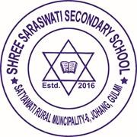
“SHREE SARASWATI SECONDARY SCHOOL”
IN

“DEPARTMENT OF COMPUTER ENGINEERING”

ON
“Enrollment and Result Management System Using C# in Visual Studio”
SUBMITTED IN PARTIAL FULFILLMENT OF THE DEGREE IN
COMPUTER ENGINEERING

DEPARTMENT OF COMPUTER ENGINEERING
National Examination Board, Sanothimi, Bhaktapur
NOV, 2023

